IMG_256

### **[点微]同城好店**

微信同城好店平台

**基础版和高级版区别**

**区别：高级版支持视频和全景，还有发布公告，还有支持设置10个字宣传语（列表也显示），还有支持发布分类信息关联：**

<http://hd.ntltsm.com/plugin.php?id=tom_tcshop&site=1&mod=article&act=vip>

[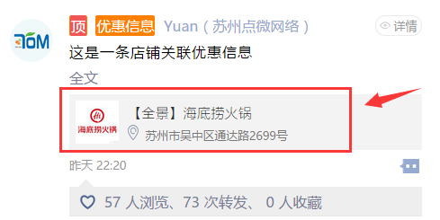](http://www.tomwx.cn/source/plugin/tom_editor/editor/attached/image/20170915/20170915073153_68846.png)

[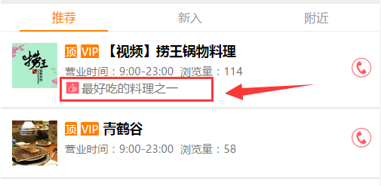](http://www.tomwx.cn/source/plugin/tom_editor/editor/attached/image/20170915/20170915073202_78029.png)

[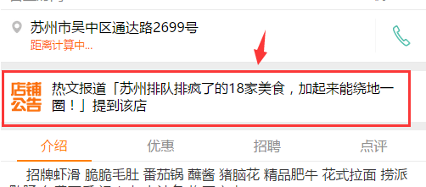](http://www.tomwx.cn/source/plugin/tom_editor/editor/attached/image/20170915/20170915073212_17285.png)

[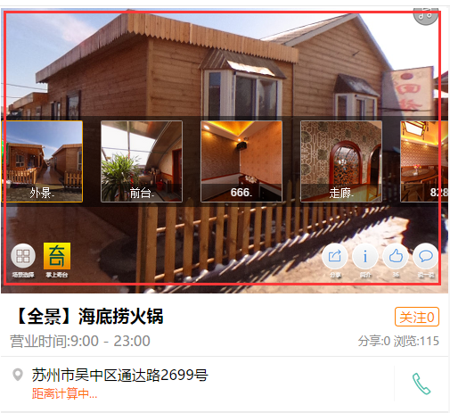](http://www.tomwx.cn/source/plugin/tom_editor/editor/attached/image/20170915/20170915073219_67199.png)

[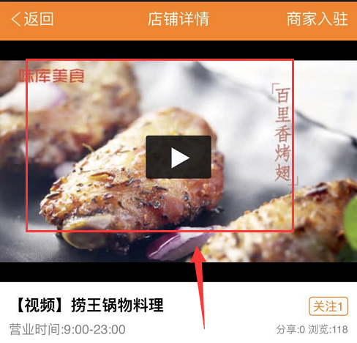](http://www.tomwx.cn/source/plugin/tom_editor/editor/attached/image/20170915/20170915073228_90690.png)